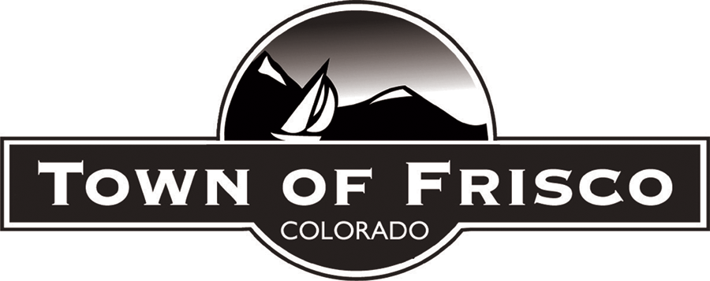

PLANNING COMMISSION

STAFF REPORT

October 15, 2020
AGENDA ITEM: Update on the Comprehensive Vision and Project Implementation Plan for the Peninsula Recreation Area

TOWN STAFF: Diane McBride, Assistant Town Manager
dianem@townoffrisco.com (970) 668-2559

Bill Gibson, Assistant Community Development Director
billg@townoffrisco.com (970) 668-9121

PROJECT DESCRIPTION

This is a work session to update the Planning Commission on the Comprehensive Vision and Project Implementation Plan for the Peninsula Recreation Area (PRA). Diane McBride, Assistant Town Manager, and Linsey Joyce, Assistant Recreation & Culture Director, will be in attendance and presenting to the Planning Commission at its October 15th meeting. This work session is intended for informational purposes, so there is no formal action requested of the Planning Commission.

BACKGROUND

The PRA is one of Frisco’s most valued assets with both summer and winter recreational opportunities. The last comprehensive plan for the PRA was completed in 2009 by DHM Design, Frisco Peninsula Recreation Area – Final Design Report. Several new amenities were constructed from this plan, including the Day Lodge, tubing hill, ski and ride hill, the bike park, and the maintenance facility. Additional planning efforts after 2009 resulted in a new skatepark, climbing boulders, nine additional holes of disc golf, and new and improved summer and winter trails. In 2016, the Town also took over the operation of the Frisco Nordic Center.

Additional planning studies were conducted after 2009, but none of these resulted in a comprehensive plan that considered all design elements. In 2019, Town Council recognized this planning gap and supported staff moving forward with a Comprehensive Vision and Project Implementation Plan for the PRA.

The Town of Frisco contracted with Lose Design to complete a Comprehensive Vision and Project Implementation Plan for the Peninsula Recreation Area (PRA) in August 2019. The goal of the plan is to identify and address operational needs, identify revenue growth opportunities, and detail the current uses and future land uses for operations, circulation, parking, storage, and recreation programs and services. The Plan includes a specific and prioritized implementation framework for the Town to use over time. The Plan is in a draft form at this time and attached for review.

A primary concern in planning for the future of the PRA is balancing the growth of recreational amenities with the preservation of its natural beauty. The consultant team, Lose Design and Sports Facilities Advisory (SFA), took a holistic approach in their evaluation of the PRA in order to create a plan that is sensitive to the PRA’s role as an important community asset as well as revenue generating operation. Outreach to the community was conducted through open houses, public meetings, stakeholder interviews, Advisory Committee meetings, and presentations to Council. The consultant team researched outcomes from previous plans, discussed operational opportunities and challenges with staff, and applied industry knowledge to create a Comprehensive Vision and Project Implementation Plan that will guide PRA growth and development in an orderly, self-sustaining manner.

The Plan is an in-depth design evaluation that considers previous ideas and reports, current uses and facilities, and desired future uses and intensities. It also identifies the purpose of the design features, their relationship to other features, and how expected outcomes will address park needs and opportunities over time.

Many of the proposed design features fulfill more than one goal. The goal categories were utilized to organize and define the value or importance of each proposed feature. All of the proposed design features are assigned to tiers to help identify their level of priority and to help with future decision-making and implementation efforts. Tier 1 items consist of high priority features considered critical to the PRA’s operational success, and include some features that will generate the highest revenues at the lowest costs. Tier 2 items are moderate priority and include those features that are important to the PRA’s operational success but not critical to maintaining recreational services. Some Tier 2 items include features that rely on the implementation of key Tier 1 items. Lastly, Tier 3 items are lower priority items that include features that have minimal bearing on operational or financial success, but support broad community goals and contribute to the overall value of the PRA.

The Plan is prioritized based on three goals:

- Implement and improve features that increase opportunities to generate funds for sustaining operations and Town initiatives, Revenue-Generating Opportunities.

This includes the Village Center, Day Lodge Renovation, Activity Center, Nordic Center Renovation, Wedding Overlook, Event Center, Ice Skating, Ropes Course, Summer Tubing, and Sleigh/Chuckwagon Concessionaire.

- Implement and improve features related to basic, logistical functions, Operational Efficiencies.

This includes Wayfinding, Transit Service, Additional Magic Carpet Lift, Maintenance Shed, By-Pass for Countywide Recpath, Additional Parking.

- Implement and improve features that enhance the overall community value and visitor experience, regardless of financial opportunity, Value-Added Enhancements.

This includes Site Furnishings and Character Elements, Public Art, Trails, Outdoor Pavilions and Restrooms, Overlooks, Playgrounds, Multipurpose Field, Screening of Maintenance Areas, Biathlon, and Community Space.

The heart of the Plan’s design focuses on the Recreation Village, which is comprised of four (4) main buildings: The Day Lodge, the Nordic Center, the Village Center (new) and the Activity Center (new). As stated in the Plan, all of the existing facilities are in critical need of upgrade and/or expansion. The highest priority features are those considered critical to the park’s operational success, and include the Village Center, the Wedding Overlook, the Community Space, and the Wayfinding System.

The Comprehensive Vision and Project Implementation Plan is a high-level view of the overall PRA operations and site design. Lose Design evaluated economically viable options for improvements that align with overall community values, Council goals, and environmental stewardship. Balancing the growth of recreational amenities at the PRA with the preservation of its natural beauty is an important consideration in planning for the future of the community. Maintaining and enhancing multi-modal access to the PRA is an important plan component. Further design development will take into account alternative transportation and multi-modal access options to alleviate parking needs, pedestrian-friendly crossings, and opportunities to showcase sustainable building practices with net-zero facilities, waste reduction practices, and innovative energy systems.

The final section of the Plan summarizes the implementation details for all of the proposed design features, including the proposed timing or importance of each feature, associated costs, and potential revenue opportunities when appropriate. The Town Council will determine the final prioritization and budgeting for the implementation of the Plan.

ATTACHMENTS

- Comprehensive Vision & Project Implementation Plan for the Peninsula Recreation Area

