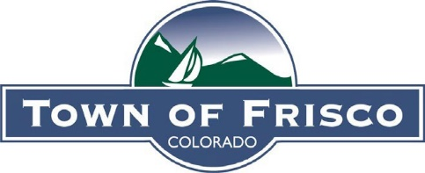

Frisco Arts and Culture Council (FACC) Meeting Minutes
January 16, 2026

- Roll Call
  - Present: Todd Altschuler, Daymon Pascual, Alison Lindsey, Diane Harty Schlaefer, Megan Testin, Jamie Callahan, Blair Miller, and Vanessa Agee.
  - Not Present: Andy Held and Melissa Sherburne
- Approval of December 5, 2025, Meeting Minutes
- Member Updates
  - Damon working on swallow shelter blueprints and understanding if the High School needs blueprints.
  - FACC affirmed that this is a good year to have passed on ice art.
- Staff Updates
  - Songwriting workshop – Blair has been working with Tyler who has secured a new lyricist, Levi Corrigan. Blair is now working with Slopeside to secure dates. Workshop capped at 15.
  - Skatepark electric box- Xcel Energy does not allow this and is doing a pilot program in the Midwest. Vanessa will reach back to Xcel in April to see if their regulations have changed. FACC suggested looking at the utility building by the Nordic Center and Recreation Way to see if a mural would be allowed there.
  - 250/150 Main Street banners
  - Blair working on Pacific Coast – public art/sculpture cleaning
- Projects
  - 250/150 Drone show review- FACC decided that August 29, 2026 might be ideal for movie night. Vanessa showed a drone show from the CASB conference. Consider having Colisco there to sell blankets. Interested in continuing to make movie night into a more signature event by keeping the DJ and the art project, and perhaps, adding new components, like a drone show. Emphasize that the drone show is a one off. Get out blanket message by having a blanket and hat door prize. Have Colisco and Ten Mile blanket there. FACC would like us to plan for a $10,000 show.
  - Swallow habitat update- Blair reached out to the Adventure Park staff, and they have concerns about attracting more swallows. Blair has reached to the bird conservancy to find out more and has followed up with them again to find out about best practices. FACC would like to create a space for the swallows and plant wildflower below a “swallow house”. Blair is continuing to track down answers about how this has worked in other areas.
  - Comedy Festival- FACC interested if the show is available to under 21 and are interested in the workshops. Would like more information on the range of sponsorship from $1k to $5k, specifics on the workshops, type of comedy, etc... Will bring information back to the FACC during the FACC meeting. FACC would like to know if we can do an in kind sponsorship of Slopeside or Day Lodge.
  - Movie night planning- FACC to bring movie ideas to the next meeting, and then we will have the public vote out of three choices.
  - 2026 future projects ongoing discussion- to continue during next meeting
- Adjourn

